(Approx. 1181 words)

WATCH A ZOOM MEETING ON YOUR HDTV
The big screen may make details easier to see and is easier to share with family members
Part 1 of a 2-part articles series
By John Krout, Presenter & Newsletter Contributor
Potomac Area Technology and Computer Society
https://www.patacs.org
jkrout.apcug.presenter (at) gmail.com

INTRODUCTION

My eyes have been much worse than 20/20 for decades. I started wearing glasses starting in 4th grade because I could no longer see the blackboard from the back of the classroom.

During the pandemic, I often participated in three or more Zoom meetings each month. Sometimes I am delivering a presentation, and sometimes I get to watch someone else do that. I saw a great one in May 2021, explaining how the latest US rover on Mars produces oxygen from the Martian atmosphere. The presenter was a principal investigator of that experiment, from MIT. The experiment involves a type of reverse osmosis and a whole lot of electric power, most of what the entire rover can produce. MOXIE's oxygen production experiment is operated primarily at night on Mars when the rover is otherwise unoccupied.

I get a bit concerned about eye fatigue when I find myself glued to Zoom on a computer screen for an hour or more.

Additionally, when I have a Zoom meeting with my daughter and her family, watching on a TV makes the image more life-size. On their end, seeing me large as life on their HDTV helps their 18-month-old learn to recognize Granddad.

Because of those concerns, I have looked into ways to watch a Zoom meeting on my big-screen TV at a distance. There are basically two methods to connect the TV to whatever device is running Zoom, whether that device is a computer, a tablet, or a smartphone:

(1) connect the Zoom device to the TV using an HDMI cable, or

(2) connect the Zoom device to the TV or a network-connected media box, using your home Local Area Network (LAN).

These techniques are not limited to Zoom alone. Since the connection methods share the screen of the computer, tablet, or smartphone, the connection methods will work with any other app running on a tablet or phone and any application running on a laptop.

This article explains how to use the two methods for Windows 10 personal computers.

THE HDMI CABLE METHOD

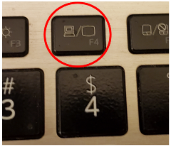
It turns out that most recent laptops and desktop computers have an HDMI output port. So you can buy a long HDMI cable to connect those to an HDTV, assuming you have not already used up all the HDMI input ports on the TV. If your TV is a 4K resolution TV, you will need a 4K compatible HDMI cable, which includes special features to prevent recording 4K movies.

This method happens to work with any HDTV, even 10-year-old non-smart TVs, and is your only choice if you have no media box connected to your non-smart TV.

Turn off your HDTV. Connect the HDMI cable to your computer's HDMI port, and connect the other end of the cable to the HDTV. Then turn on the HDTV, and set its input to the HDMI port to which you attached the cable.
Illustration 1

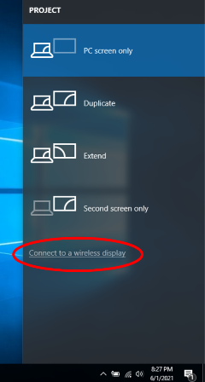
You may need to tell your computer to send video out through the computer's HDMI output port. For example, on my Windows 10 laptop, I use a function key: a key with pictograms of the laptop screen and an external TV. You can see that function key circled in illustration 1.

THE LAN METHOD

This method only works when some display device, either the HDTV itself or a media box, such as Roku or Chromecast or a Blu-ray player, is connected to your home LAN by either WiFi or ethernet.

If you run a VPN client app on your computer, you will have to shut down the VPN client. While the VPN client is active, your computer cannot connect to your smart TV, Roku, or Chromecast device from the viewpoint of your network.

CASTING FROM A WINDOWS 10 LAPTOP

To test this capability, I connected my LG smart TV to my LAN using an Ethernet cable.

Make sure your Windows 10 computer is connected to your LAN and is not connected to an HDMI cable. Also, make sure your TV is turned on and connected to your home LAN.
Illustration 2

STEP 1. On your Windows 10 computer, tap the function key that enables output to a TV. An example of that key is shown in illustration 1. One two laptops I have examined, that is the F4 key.

The Windows 10 computer displays a menu on the right side of the screen, like the menu shown in illustration 2.
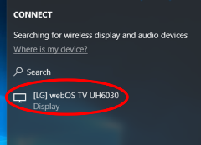
STEP 2. Select the Connect to a wireless display option in the menu, which is circled in the illustration.

The computer scans the network for connected display devices. This can take a minute or so. In my case, since I had connected my LG HDTV to my LAN via an ethernet cable a few minutes earlier, the computer found the TV. You can see the computer's report about the TV in illustration 3.
Illustration 3

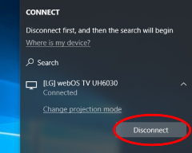
STEP 3. Click on the TV choice, which is circled in illustration 3. Establishing the connection to the TV may take a minute or more.

STEP 4. The TV itself might ask for your permission to connect to the computer. If that happens, then use your TV remote control to select Accept or Yes or OK. My LG TV did not ask for permission.

STEP 5. The TV displays the screen of the computer. It is now possible to run Zoom or any other computer application and see the application on both the computer screen and the TV.
Illustration 4

On the computer, you will see a report that the TV is connected and a Disconnect button, shown in illustration 4.

At this point, you can make the menu disappear by tapping the ESC key.

TO END THE CONNECTION

Again, tap the function key to make the menu appear on the right side of the screen. For example, you can see the menu in illustration 4.

In that menu, click the Disconnect button.

That is all it takes.

WEBCAM POSITION

If you are an active participant in a Zoom meeting, so you want to be seen, the best way to do that while using a TV as the display is to put your webcam close to the TV. If you use a laptop with a built-in webcam, you should put the laptop very close to the TV, perhaps just above or below the TV.

This ends Part 1. Part 2 will explain connecting an Android tablet or smartphone to your TV using the two methods.

ABOUT THE AUTHOR: John Krout has been writing about creative uses of personal computers since the 1980s. He is a frequent contributor to PATACS Posts, the newsletter of the Potomac Area Technology and Computer Society, and occasionally provides presentations at PATACS meetings. He lives in Arlington, VA, with his son, many computers and digital cameras, and too many cats.

